AshCom

Release Notes document

Revision history

Ashcom v3.0.38 12-May-2011

a_viewer.dll has been updated:

1. ATOM V.2 support
2. L5 SNR visualization (from ATOM,PVT only)
3. GALLILEO satellites visualization (NME,SAT and ATOM,PVT)
4. GPS week number visualization (from ATOM,NAV only)

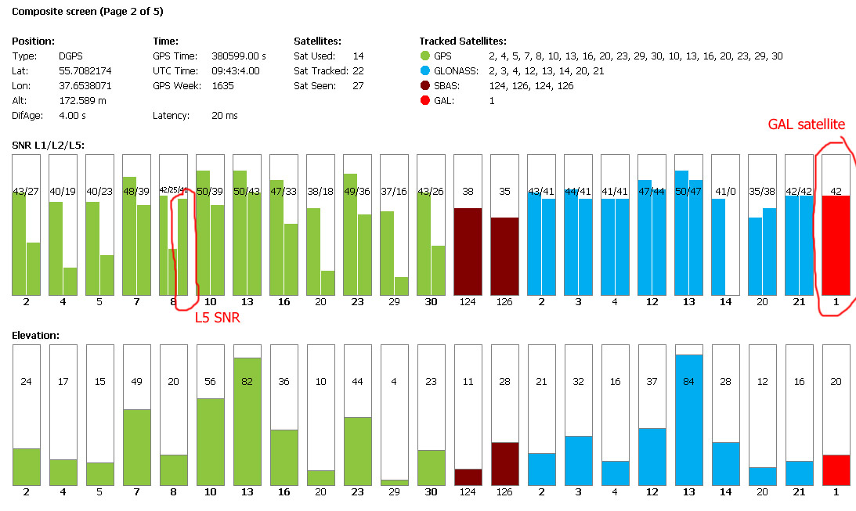

Ashcom v3.0.37 19-Jan-2011
- DLL pipe bug fixed which sometime caused data corruption
- TCP/IP server DLL bug fixed
- Help updated

Ashcom v3.0.36 28-Dec-2010
- IP data transfer bug fixing
- GUI bug fixing
- BP1 description added (file BP1.ini)

Ashcom v3.0.35 21-Dec-2010
- cycle buffer mutex protection added
- screen buffer disabled (weak PCs optimization)

Ashcom v3.0.34 25-Nov-2010
- cycle buffer bug fixed
- srv_sock - max connections increased upto 32

Ashcom v3.0.33 11-Nov-2010
- Internal variables are not stored in registry
- parse command added
- progr command added
- msg 2 command added
- terminate command added
- execw command addd
- bug with end of line in CEdit on some PCs fixed
- F1..F9 and capital letters support in evt kb added
- ser0.dll is used
- sock_srv.dll max connections increased to 32

Ashcom v3.0.32 07-May-2010
- xmodem bug fixed

Ashcom v3.0.31 06-Apr-2010
- dlls as separate threads
- dll data alignment bug fixed

Ashcom v3.0.30 15-Feb-2010
- sock_rx.dll - automatic reconnect added
- Text output - scroll to the bottom added

